A000-Cook Voyages-Engravings

**1785 Capt James Cook "Habitans et Habitation de l'Entree de Norton"**

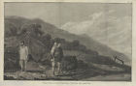

**1790 Cook Hogg Antique Print of a Dead Chief in Tahiti**

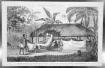

**Cook: Hawaii Ship Catamaran Masked Warriors – 1774**

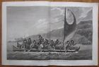

**1786 John Webber HAWAII King Kalaniopu'u Flotilla Greets COOK Kealakekua Bay**

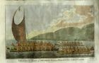

**1777 Original CAPTAIN COOK VOYAGE Copper Plate FAMOUS FRONTISPIECE PORTRAIT**

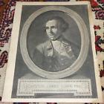

**1785 Capt James Cook---two Tahiti engravings**

**No pictures available**

**1786 John Webber KAUAI TEMPLE BURIAL PLACE "Morai" HAWAII Captain Cook Voyages,**

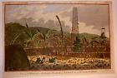

**1785 William Hodges WAR CANOES OF TAHITI - Grand Flotilla! Captain Cook Voyages**

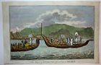

**1786 John Webber TONGA "Fa'itoka" Sylvan Burial Ground Tongatapu COOK VOYAGES**

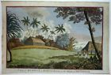

**1784 Sydney Parkinson TAHITI BOATS & FISHERMEN ISLAND VIEW Captain Cook Voyages**

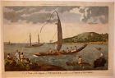

**1780 Cook Antique Print of a Morai, Kauai Island Hawaii**

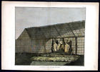

**Cook: Alaska – 1774**

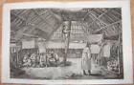

**Cook, Landing Scene Vanuatu -1774**

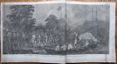

**Cook: Man Mallicolo Vanuatu - f741 – 1774**

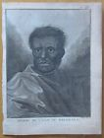

**Cook: View of Tahiti Danse – 1774**

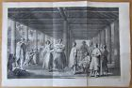

**Cook: View of Tahiti Ship – 1774**

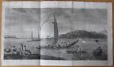

**Cook: View of Tahiti – 1774**

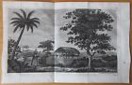

**Cook: War Ship Pirogue de la Guerre New Zealand – 1774**

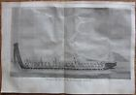

**Cook: View Ulietea Polynesia Ship – 1774**

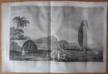

**Cook: *Portrait People Pacific Man Tanna Vanuatu – 1774**

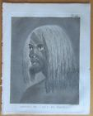

**Cook: *Portrait People Pacific Tattooed Chief Marquesas Polynesia – 1774**

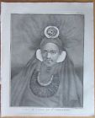

**\*Man Hawaii Dancer – 1774**

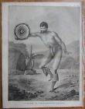

**Dance of Men Hapaee Friendly Islands Tonga – 1774**

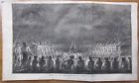

**Cook: Poulaho King Friendly Islands – 1774**

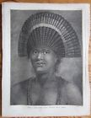

**Cook: Original Engraving New Zealand Warrior Tattoo Guerrier – 1774**

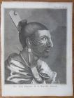

**Cook: View Frensh Polynesia - f588 – 1774**

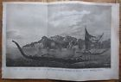

**Cook: Tahiti Ships Fleet - f574 – 1774**

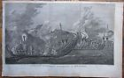

**Anamooka Tonga Friendly Islands – 1774**

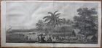

**Cook: *Man from Mangea Vanuatu – 1774**

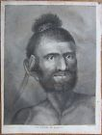

**Cook: *Boxing Hapaee Friendly Islands - 1774**

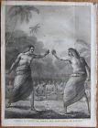

Cook- **Dance of Women Hapaee Friendly Islands Tonga – 1774**

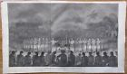

**Cook: Friendly Islands Tonga Cava Ceremony – 1774**

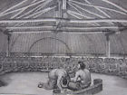

**COOK VOYAGE Copper Plate TAHITI BURIAL CEREMONY Toupapow**

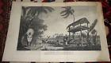

**View Marquesas Pacific Ship – 1774**

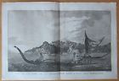

Cook- **Human sacrifice ritual in Tahiti ca.1780's**

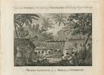

Cook- **Isaac Taylor. A view of Karakakooa in Owyhee. 1820**

